English Vocabulary:

machine/appliance/device/tool (C)

equipment/machinery/apparatus (UC)

A) Countable (individual things)
1. machine (PT: máquina, eletrodoméstico)

Definition: A piece of equipment, usually electrical, which has moving parts.
Examples: washing machine, sewing machine, lathe
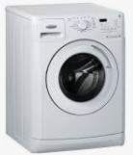

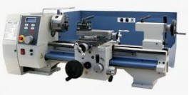

2. appliance (PT: utensílio, eletrodoméstico)

Definition: A piece of electrical equipment for domestic use.
Examples: refrigerator, vacuum cleaner, mixer

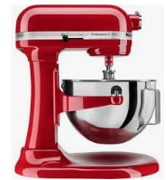
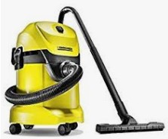
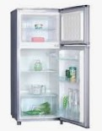

3. device (PT: dispositivo eletrônico, aparelho)

Definition: A piece of equipment (usually electronic) made for a specific purpose.
Examples: smart phone, tablet, smart watch, games console, router
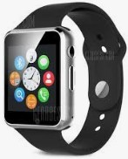



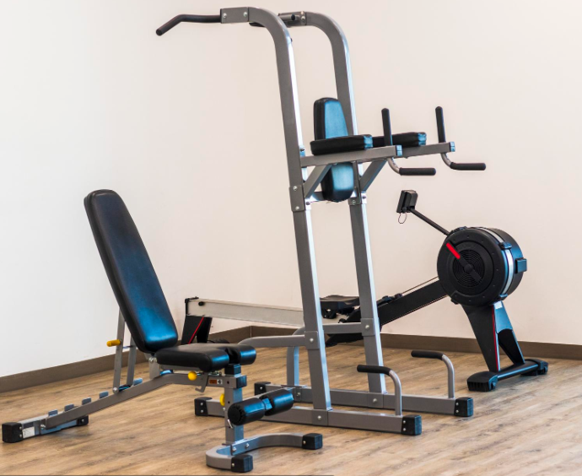
4. tool (PT: ferramenta)

Definition: An object, usually held by hand, used for a specific function.
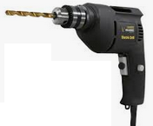
Examples: hammer, screwdriver, wrench/spanner, pliers, saw
Electric tools: electric drill, electric saw
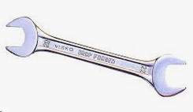

B) Uncountable (collective things / sets)

1. equipment (PT: equipamento)

Definition: A general word which represents “all the necessary items for a particular purpose”.
Examples: climbing equipment, fire-fighting equipment



2. machinery (PT: maquinário, mecanismo)

Definition: a) many machines, b) the components of a machine
Examples: a) farm machinery (tractor, combine harvester, etc.)
b) cogs, nuts, bolts, etc.
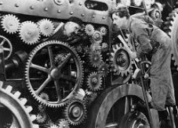


3. apparatus (PT: aparelho)

Definition: The technical equipment needed for a particular activity.
Examples: chemical apparatus (in a laboratory), exercise apparatus (in a gym)

